**SODV 3203: MOBILE APPLICATION DEVELOPMENT**

**PROJECT PROPOSAL – SOCIAL MEDIA MOBILE APP**

**By Lateef Azeez – BVC: 415453**

**Proposal Overview**

This proposal describes my intended project for the completion of the Mobile Application Development course as a proof of concept in the course. The project will be a Social Media Mobile app which would be used to connect people with different interests from all parts of the world.

Currently there are millions of mobile apps with several features from connecting people to audio and video chatting, to updating profiles and status and the likes, but there are few of them who actually combines more of these features into one. Many of the existing apps are focused on one or few features which in most cases is chatting. My intention to build this app is to incorporate the power of real connections between people, therefore this app would connect people through a specific interest as I believe the present-day social media requires more in-depth connections to really make it worthwhile.

**Project idea**

This project Idea comes from the fact that the present-day social media users require more than an online friendship with no specific thing in common. There is a great need to be really connected to someone through something, this makes friendship more meaningful and could lead to a lot of networking and lots more.

The app name would be connectMe App.

**App Features**

As I have discussed above, this app would connect people with a common interest, allow chatting but audio and video and users would be able to create profile and show online status. Some of the features of the app are as listed below;

* A Registration and Login Screen using firebase authentication
* User profile creation
* View profile and interests
* Username and password recovery
* Google Sign-in feature
* Search and view registered users
* Chatting
* Viewing Online Status
* View Typing Status
* Delete Message
* Send Message notifications
* Publish Posts
* Show, Search edit and delete Posts
* Send and receive images in chat
* Notification Screen
* View people who liked posts
* Block and unblock users

**Wireframes**

The following mark-up images describe briefly some of the pages as would be present colourfully on the real app. Though some might change during my development stages but the whole idea would still remains.

1. Register Page 2. Sign In Page

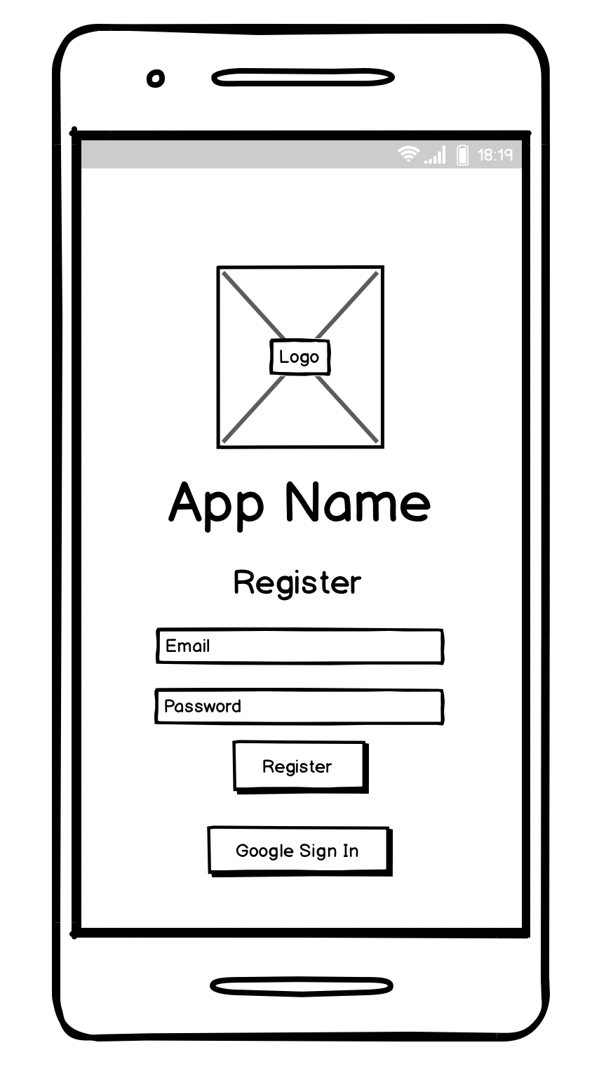

3. Profile Page 4. Users Page

5. Chat Page 6. Posts Search Page

7. Post Details Page

